Sparrows Point Middle School
Behavior Intervention Plan
2022-23 SPMS Behavior Intervention Plan.docx


Principal
Jennifer Gounaris

Assistant Principal
Kathleen Owens

Assistant Principal
Matthew Wickman

Sparrows Point Middle School
Behavior Intervention Plan
2022-2023

At Sparrows Point Middle School….

A positive climate is the greatest gift we can give our students.

Our student support model approach:

Prevention

Logical
Consequences

Restoration

This We Believe

Every child deserves a champion – an adult who will never give up on them, who understands the power of connection, and insists that they become the best that they can possibly be. – Rita F. Pierson
- We are guided by acceptance of diversity and unique differences.
- We understand that discipline is taught through connecting, coaching, and providing feedback.
- Everyone has opportunities for comebacks.
- We are a unified school community. This is a partnership between administrators, staff, parents, and students.
- We operate as a team (staff, students, admin, and parents) to implement behavioral expectations consistently and conscientiously and to teach empathy.
- We stand for a high level of respect for ourselves, our peers, our school, and our community.
- We are creating productive and responsible citizens.

Sparrows Point Middle School Code of Conduct
At Sparrows Point Middle School we have PRIDE when we…
 Practice safe behaviors
Respect our self and others
Interact with empathy and inclusivity
Demonstrate responsible citizenship
Exercise high academic standards

Description of Roles

All Staff:
- Interact with students in a manner that de-escalates student behavior.
- Call for assistance of administrator for immediate concerns.
- Enforce school policies throughout all common spaces regarding language, dress-code, hall passes, electronic devices, and student behavior.

Classroom Teachers:
- Implement consistent, conscientious, and timely classroom level interventions.
- Keep timely and accurate records of attendance, lateness, and behavior interventions in SIS.
- Document prior interventions/parent contact on ASD and office referrals.

Department Chairs/Team Leaders:
- Provide disciplinary support to classroom teachers in instances that do not require the involvement of an administrator.
- Provide timely and meaningful feedback about classroom environments.
- Ensure that all teachers have a pre-determined alternate setting (buddy teacher) for disruptive students.

Social Emotional Learning Teacher:
- Assist in the development and implementation of the school-wide behavior management plan as well as individual student behavior management plans.
- Provide support to teachers, students and parents in employing proactive approaches for behavior management.
- Assist staff in teaching and/or co-teaching social skills, anger management strategies, and conflict resolution skills to classes, small groups, and individual students.
- Develop and implement procedures for crisis intervention strategies and techniques.
- Gather, analyze, and maintain data related to student behavior.
- Collaborate with administrators and academic teams in order to refine positive behavior interventions and the school wide discipline plan.
- Provide intervention strategies in the classroom to address behavior challenges.
MTSS Resource Teacher
- Provides weekly discipline reports to Grade Team Leaders.
- Facilitates restorative conversations for students in ALC, returning from suspension, or receiving multiple detentions.
- Facilitates pre-SST planning and data collection and participates in SST problem-solving.

Administration:
- Manage school-wide student behavior and assign consequences as appropriate.
- Provide timely and meaningful feedback to staff who have sought assistance with student behaviors.
- Confer with the teacher directly involved in an office referral prior to the student returning to class.

Crisis Intervention Team

The crisis intervention team works collaboratively to provide immediate assistance in times where the safety of self and others is of the utmost urgency.

- Administrators
- SRO
- Social Emotional Learning Teacher
- MTSS Resource Teacher
- IEP Chair
- Special Educators
- Nurse
- School Social Worker

This team will meet monthly to discuss chronic behavioral concerns, review school-wide data and identify additional supports to address individual student needs through a “whole child” lens. This will include counselors, nurse, school social worker, and Children’s Guild.

Procedures to Follow for Immediate Assistance

Response Protocol:
In the event the crisis team is called. Staff should respond with the following:
- This is ___, I am on my way. Or this is ___, I am unavailable.

Call Office:
- Ms. Lookingland
- Mrs. Shelley
- Ms. Jarrard
They will walkie the crisis team.

- Administrators
- SRO
- SEL/MTSS
- IEP Chair
- Special Educator

Procedures to Follow for Minor Intervention

Call the Team Leader to have a Safety Assistant escort the student to the Grade Team Leader’s room.
6th Grade (McQuaid) – 7712
7th Grade (Stack) – 7689
8th Grade (Rizzi) - 7736
If behavior continues to be disruptive of the learning environment, a student may be sent to the Grade Team Leader’s room.


Behavior Management Policy
Does Behavior Go Immediately to an Administrator?
*See next page for special circumstances. *

Tier I – Classroom Interventions and Communications

Steps for Teachers in handling student behaviors

- Address the behavior with student privately (after)
- Assign consequences as needed (teacher discretion)
  - Phone Call
  - Grade Team Leader Time-Out
  - Lunch Detention
  - After School Detention
- Communicate with parents (phone and email – document on FOCUS)
- Team Leaders will assess weekly discipline reports.
Teacher Managed Behaviors

- Failure to follow directions
- Refusing to cooperate with school rules
- Refusal to do assigned work
- Refusing to serve detention
- Inappropriate language
- Cell Phones
- Academic dishonesty (forging signature of teacher and/or parent/guardian)
- Unexcused Lateness (class/classes)
- Unexcused absence or truancy (class cutting)
- Horseplay
- Play fighting
- Unsafe behavior
- Disruption
- Inappropriate behavior towards teacher or student (s)
- Passive aggressive behavior
- Disrespectful statements
- Minor vandalism
- Use of electronic devices without permission (for non-instructional purposes)
- Harassment of other student(s)

Tier II – Team Leader

Steps for Team Leaders

- Address the behavior with student during Advisory period
- Restorative conference between teacher and student
- Set up a BIP – Behavior Charts – Check-in/Check-out schedule, if necessary
- Assign consequences as needed (team leader discretion)
  - Phone Call
  - Lunch Detention
  - After School Detention
- Communicate with parents (phone and email – document in FOCUS)
- Team Leaders communicate escalating interventions to grade-level Administrator

Tier III – Administrators

Team Leader will complete referral to Administration with appropriate documentation completed.

- Administration will communicate/confer next steps with Team Leaders and Teachers.
- Administration will apply consequences according to the BCPS Discipline policy and Student Behavior Handbook.

Tier III Special Circumstances: These behaviors would be a direct referral to administration in extreme circumstances.

Tier III – Administrators

Team Leader will complete referral to Administration with appropriate documentation completed.

- Administration will communicate/confer next steps with Team Leaders and Teachers.
- Administration will apply consequences according to the BCPS Discipline policy and Student Behavior Handbook.

Administrator Managed

- Elopement
- Fighting
- Aggressive Physical Contact
- Threatening Language
- Chronic Harassment/Bullying (in person/social media)
- Smoking, Vaping, & Illegal Drugs
- Gambling
- Weapons
- Major Vandalism
- Theft
- Arson
- Truancy (class cutting – multiple occurrences)
- Transportation behaviors

Arrival and Dismissal Procedures

Arrival Procedures 7:50 – 8:05
- Students who need to come upstairs early MUST have a pass each day.
- Students with passes must remain with the teacher at all times.
- Students should be in homeroom before announcements begin. End of music will signal the start of homeroom.
- The first bell rings at 8:05.
- Students must be in homeroom by late bell at 8:05.
- Students eating breakfast should be directed to take their breakfast to homeroom at 7:50. (Only food purchased from the cafeteria may be brought upstairs.)
Dismissal Procedures 2:50- 3:05
- Students should exit the building immediately and remain out unless they are under the supervision of a teacher.

Clothing

- No hats of any kind (including bandanas)
- No clothing which shows a student’s undergarments (pants should cover entire seat area)
- No clothing which has inappropriate language and/or pictures
- No midriff-bearing clothing

Hats must remain off for the entire school day. Staff members who observe a student wearing a hat will ask the student to store the hat in their lockers. Students wearing hats during the school day will be assigned a consequence based on the tiered Behavior Management Policy.

Hall Passes

It is imperative that all staff be able to identify students in the hallway. In the event of an emergency, teachers need to know who is in and out of the classroom at all times. By following the procedures below, we can keep our school safe.

- A student ID card, sticky note, etc. is not considered a hall pass.
- Passes – Each teacher will have a designated pass in their classroom for students to use when leaving the room. *one single student out of the room at a time*
- Teachers should implement bathroom procedures within their classroom at their discretion.
- All staff and students should observe the “10-10” rule: no passes during the first or last 10 minutes of class, unless it is an emergency situation.
- No more than one student should be out of a classroom at any time, unless in an emergency situation. Students may only access lockers before school and at the conclusion of the school day.
- If a student arrives to your class without a pass, do not send the student away in search of a pass. Please mark the student tardy in FOCUS.
Main Office

Please remember that the office is a professional setting. Many parents, central office staff, and community members transition through our front office on a daily basis and this environment will become their first impression of our school culture. As such, it is important to contribute to the overall welcoming atmosphere for our visitors. You can support this by:

- Not engaging publicly by speaking about students in such a way that shares private information.
- Office staff will not use speaker phone setting during the school day to maintain confidentiality.
- Encouraging students to not eat in the office lobby.
- Not using cell phones in office.
- Having confidential conversations with parents in an alternative space.

Lunch Detention

- Given for classroom-managed behaviors listed on page 6.
- Lunch detention slips are carbon-copied
  - One for the student
  - Staff sends envelope to office during Advisory (6th & 7th) or 5th Period (8th)
  - Ms. Jarrard inputs data into FOCUS
  - Teacher is still responsible for parent contact, if necessary
- Student goes to lunch detention in room 220 (6th & 7th) and room 222 (8th) before the cafeteria. Students will be escorted to lunch line reserved for lunch detention. Given a time limit.
- SEL, MTSS Resource Teacher, or Security will review slips for repeat offenders or students who skip detention.

After School Detention

- Given for repeated classroom-managed behaviors (and repeated lunch detentions) listed on page 6.
- Teacher may use discretion to assign ASD after two lunch detentions have been issued.
- Students will go to ASD location at the end of the school day and complete the behavior reflection.
- Students will complete community service to the school while in ASD.
- Security will review slips and monitor students until dismissal.

Removal From Classroom

- Universal referral slip has been provided and MUST be completed when sending a student out of the classroom.
- Teacher should call the Team Leader when student leaves, so they are aware of the student’s arrival.
- 6th Grade (McQuaid) – 7712
- 7th Grade (Stack) – 7689
- 8th Grade (Rizzi) - 7736
Cell Phones/Electronic Devices

Sparrows Point Middle School staff believes in promoting a safe school climate that upholds high standards for creating digitally responsible citizenship. We believe in creating educational spaces that are focused on learning, collaborating, and fostering positive peer to peer interactions. All students have 1:1 devices and are provided ample opportunities for technology integration throughout the instructional day.

As such, the cell phone policy for Sparrows Point Middle School is as follows:
- Cell phones are not allowed to be seen in hallways or classrooms for any reason.
  - If a staff member asks a student to put a cell phone away, it must be done the first time, in a courteous manner or a consequence may be assigned.
- Cell phones/personal electronic devices will be allowed during lunch.
*We recognize that there may be a need for a child to call home. In this case, there is a phone located in the office for students to contact their parents. If there is a need for parents to contact their child immediately, they may call the school office at 443-809-7524.
Progression of Discipline within a Class Period
First Offense | - Staff tells student to make sure phone is off and away.
Second Offense | - Teacher assigns lunch detention.  - Office will document in FOCUS.
Third Offense | - School safety escorts student to place device in locker.  - Teacher communicates with the student’s family.  - Teacher assigns ASD.  - Teacher documents in FOCUS.

If repeated pattern arises from cell phone use, MTSS staff will develop cell phone use plan for student.
Cell phone expectations for students:
- ALL personal electronic devices should be turned off and stored for the full school day.
- Willingly place device in locker should an infraction occur.
Cell phone expectations for teachers:
- Utilize personal devices for professional purposes during instruction.
- Use the video and camera features to celebrate student achievement.
- Model appropriate social skills while managing a variety of technology tools.

For more detailed information regarding Technology Acceptable Use Policy for Students see the BCPS Student Handbook.

Common Area Behavior Expectations

Common Areas are defined as spaces where students travel or exist in groups which are unstructured.

- Walk on the right side of the hallway to prevent congestion
- Earbuds must be put away (not in/around ears and not around neck) because students cannot hear directions, teachers, or alarms.
- Voice level must be moderate so that announcements and directions can be heard.
- Do not touch other students because it can escalate into unsafe behavior.

Teachers should demonstrate and model procedures. They should also explain why these rules are in place and use visuals and banners to help students remember. It is expected that all staff members will greet students at their classroom door upon class change.

Cafeteria Expectations

- Expectations:
  - Bring everything they need to the cafeteria (money, lunch, snacks, drinks)
  - Enter lunch line for food ONCE
  - Raise hand for permission to visit nurse or use bathroom
  - Must have a pass for lunch bunch/extra work
  - Each student must have an individual pass
  - Tables will be dismissed by an adult only when the area is clean
- Procedures:
  - Lunch Duty
    - Everyone must report to their lunch duty in a timely manner
    - If a staff member cannot attend their lunch duty, they should notify the office as soon as possible
  - Written passes must be given to a student for lunch bunch/extra work
  - Misbehavior in the cafeteria
    - Students will be directed to “time-out” table
    - If refusing or continuing disruptions, staff members may issue lunch detention or after school detention.

Advisory

Advisory will be held daily, school-wide, focusing on Social Emotional Learning, Career & College Readiness, Math, PBIS, and AVID skill development for students and teachers. The advisory curriculum is aligned with The American School Counseling Association’s Mindsets and Behaviors for Student Success.

Goals of Advisory:
- provide safe spaces that encourage shareholders to engage in honest dialogue.
- help students to feel a sense of belonging with their school community.
- provide equitable opportunities for all students.
- reduce the suspension rate.
Teacher Expectations:
- provide a student-centered safe environment in their classrooms.
- Establish class norms, expectations, and consequences for the group *for breach of confidentiality*
- Be an attentive listener
- Make sure that viewpoints of all students are heard and that no single student dominates the discussion.
- Immediately report behaviors that could be considered self-harm, harm to others, and/or child abuse to school counseling.

Student Expectations:
- Be an active listener and openly participate in discussions
- Respect the privacy and confidentiality of all peers in the group
- Follow the established class norms and expectations

The American School Counseling Association’s Mindsets and Behaviors for Student Success
Mindset Standards |  | Behavior Standards
- The belief in development of whole self, including a healthy balance of mental, social/emotional and physical well-being
- Self-confidence in ability to succeed
- Sense of belonging in the school environment

- Understanding that postsecondary education and life-long learning are necessary for long-term career success

- Belief in using abilities to their fullest to achieve high-quality results and outcomes

- Positive attitude toward work and learning and learning Cat

Learning Strategies
- Demonstrate critical-thinking skills to make informed decisions
- Demonstrates creativity
- Use time-management, organizational and study skills
- Apply self-motivation and self-direction to learning
- Apply media and technology skills
- Set high standards of quality
- Identify long-term and short-term academic, career and social emotional goals
- Actively engage in challenging coursework
- Gather evidence and consider multiple perspectives to make informed decisions
- Participate in enrichment and extracurricular activities
Social Skills
- Use effective oral and written communication skills and listening skills
- Create positive and supportive relationships with other students
- Create relationships with adults that support success
- Demonstrate empathy
- Demonstrate ethical decision-making and social responsibility
- Use effective collaboration and cooperation skills
- Use leadership and teamwork skills to work effectively in diverse teams
- Demonstrate advocacy skills and ability to assert self, when necessary
- Demonstrate social maturity and behaviors appropriate to the situation and environment

Self-Management Skills
- Demonstrate ability to assume responsibility
- Demonstrate self-discipline and self-control
- Demonstrate ability to work independently
- Demonstrate ability to delay immediate gratification for long-term rewards
- Demonstrate perseverance to achieve long-and short term goals
- Demonstrate ability to overcome barriers to learning
- Demonstrate the effective coping skills when faced with a problem
- Demonstrate the ability to balance school, home and community activities
- Demonstrate personal safety skills
- Demonstrate ability to manage transitions and ability to adapt to changing situations and responsibilities.
PBIS

Positive Behavioral Interventions and Supports (PBIS) is an evidence-based three-tiered framework to improve and integrate all of the data, systems, and practices affecting student outcomes every day. PBIS creates schools where all students succeed. Cultural responsiveness includes holding high expectations for all students, using students’ cultures and experiences to enhance their learning, and providing all students with access to effective instruction and adequate resources for learning.

Goal: Our approach to encouraging positive school behavior is understanding how the effects of school systems on each student is critical to achieving equitable outcomes for ALL students. Our core goal is establishing a positive school culture that includes setting up the school’s social environment (either intentionally or unintentionally) to reflect a shared vision of common values, beliefs, and behavior expectations.

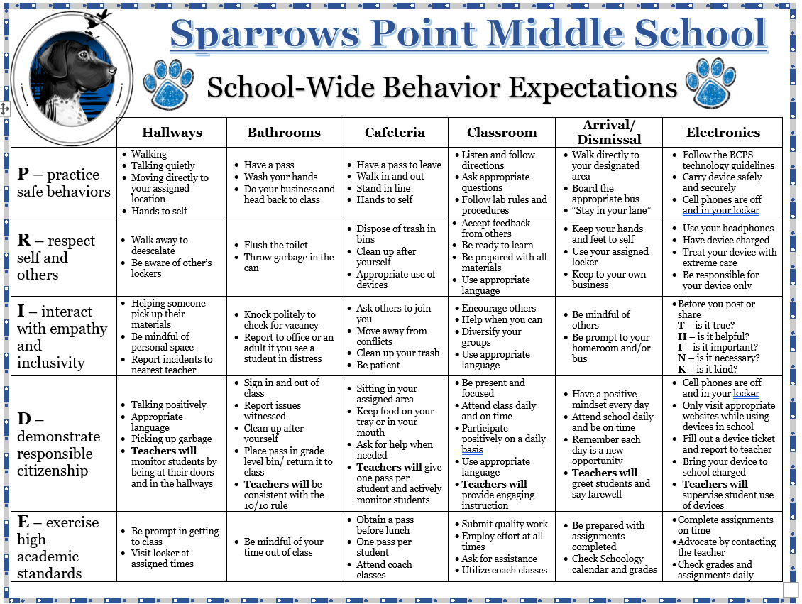

With a coaching mindset, it is recommended that team leaders touch base with their grade level teams bi-weekly to determine which students are in danger of not meeting the criteria and offer encouragement. Team leaders with students who are not meeting goals should follow the steps in our School-Wide Positive Behavior Plan.

